Civic Hospital Neighbourhood Association (CHNA)
2013 Membership Dues $5 per household
About Us
The Civic Hospital Neighbourhood Association is a volunteer non-profit community group of residents representing 2000 households adjacent to the Civic Hospital campus of The Ottawa Hospital.
The CHNA boundaries are Hwy 417 on the north, Railway St on the east, Carling Ave on the south, and Island Park on the west.

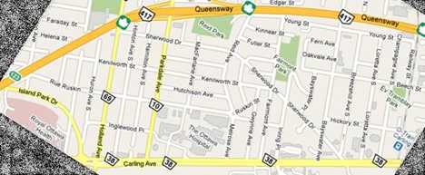
Mission Statement
Our mission is to promote the general interests and wellbeing of the residents of the Civic Hospital area in the City of Ottawa. We will do this by promoting and protecting the interests of the community with respect to the planning and future development of the community. We will support programs which provide for the safety of community residents. We will communicate local news and events of interest to community residents and conduct, promote and encourage social/recreational activities within our community.
We will also work with all levels of government on matters of concern to the community.

