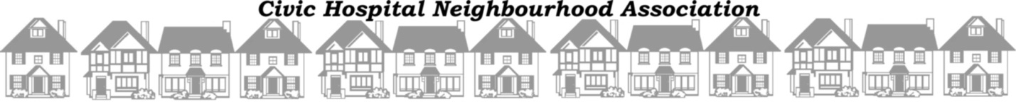

November 1, 2012

Dear Bailey,

On behalf of the Civic Hospital Neighbourhood Association (CHNA) I would like to thank you for your time and assistance on Saturday October 20th in making our second annual Pumpkins in the Park event a huge success!
We appreciate that you donated three hours of your time as a volunteer face painter and stayed after the event to assist with the cleanup. The kids really loved your work!
Thank you for your time and making our community event such a huge success!

Sincerely,

Amanda Farris, MBA
CHNA President
613-866-4089
CHNA4U@gmail.com

