Introduction
CHNA Planning and Development Tool Kit is designed to provide an overview of the guiding principles of CHNA Planning and Development Committee, followed by examples of proposed developments and trying to apply guiding principles, overview of City of Ottawa Official Plan, Zoning, resources and links to guide you in planning and development processes. To navigate throughout this tool kit, you may click on the Content hyperlinked headings below to go directly to the section of interest. And, you may click on any hyperlinked headings within this document, that will bring you back to this Content page.
Content
- CHNA Planning and Development Committee’s Guiding Principles
- Examples of Proposed Developments and Trying to Apply Guiding Principles
- City of Ottawa New Official Plan
- City of Ottawa Zoning By-law Review
- Intensification Plans
- Community Design Plans
- City of Ottawa Planning and Development Slide Presentations
- Interesting Planning and Development Measures
- Key Links to Resources
- ANNEX A (Pages 13-16): Near Future and Ongoing Focus: Three Different Developments Impacting Our Community, including chart overview of CHNA ACTIONS with Three Different Developments
- ANNEX B (Page 17-18): Impact of Surrounding Developments on Preston Street and Carling Avenue
*To provide feedback and suggest further resources for this document, please send an email to: info@chnaottawa.ca And, to learn more about latest happenings checkout Civic Hospital Neighbourhood Association (CHNA) website.

A. CHNA Planning and Development Committee’s Guiding Principles
CHNA Planning and Development Committee operates on the basis of the following principles:
- Enhancing – Protecting – Preserving our Neighbourhood - Urban neighbourhoods such as the Civic Hospital neighbourhood are the heart of the City of Ottawa and that the essential integrity of this and other urban neighbourhoods must be enhanced, protected and preserved.

- Responsible Development within CHNA Boundaries - Development within CHNA boundaries is good for the community, as long as the development is sensitive to the heritage and design values of the existing neighbourhood and respectful of current residents.

- Resident-Centred Approaches to Decision Making on Planning and Development - Healthy neighbourhoods are, by their nature, resident-centred, therefore planning and development decisions must include bottom-up planning and meaningful consultations with current residents.

- Inclusive Neighbourhood - Neighbourhoods function best when they include a wide range of housing, income levels, demographics, local businesses, local services, sustainable ecosystems, safe streets, appealing public spaces and accessible meeting spaces for the community to come together.
B. Examples of Proposed Developments and Trying to Apply Guiding Principles
In the past year, CHNA Planning and Development Committee has expanded with the formation of a new sub-committee - 1081 Carling Avenue Sub-Committee. This sub-committee is serving as a case study, where residents are donating funds to hire a lawyer, planners, to aid in planning ways forward to address the two high rises (22 and 28 storeys), proposed by Taggart development for this site. We are paying attention to how this sub-committee progresses, since we anticipate in the near future, other areas in our neighbourhood could require similar support - Where development proposals, do not adhere to preservation and heritage of our mature community, and/or present zoning by-laws.
While CHNA Planning and Development Committee supports 1081 Carling Avenue Sub Committee, we also balance efforts in collaboration with City Planners and Staff, City Councillors, developers, architects, and Federation of Community Associations and other stakeholders, to aid in responsible intensification in our community. And, at the same time, we help citizens with potential Committee of Adjustment presentations, appeal processes, and guidance on applying potential approaches and tools.
Each step we take matters – Even if it’s not an immediate win, the presence we provide and the actions we take to ensure responsible development for our residents, make a difference.

How CHNA supports new builds, and at the same time, works hard to protect our mature neighbourhood’s streetscape character –
Example of how City of Ottawa’s Committee of Adjustment turned down proposed variances for attached and integrated garage
Our neighbourhood continues to face increased pressure from developers wanting to buy homes in our area on larger lots. Then, developers work on plans to split the lot into two, and build two homes with front facing attached garages. This trend seems to be unfolding with speed. With this in mind, we have seen examples of decisions reached by City of Ottawa’s Committee of Adjustment to turn down proposed variances for a property requesting an integrated garage.
Next section covers how CHNA is also learning how even if City of Ottawa’s Committee of Adjustment turns down a proposal for attached and integrated garage, it’s possible this decision could later be overturned by Ontario Land Tribunal.
What CHNA has learned from proposed variance to build an attached garage, that was rejected by City’s Committee of Adjustment, and approved by Ontario Land Tribunal
CHNA tries to serve, when possible, to protect the maturity of our neighbourhood at City of Ottawa’s Committee of Adjustment. Residents from a property may put forward their proposed variance to build a front facing garage attached to their existing dwelling. Their proposal could be rejected by Committee of Adjustment, and then residents may file with Ontario Land Tribunal to appeal this decision.

For your information, here is a link to search for properties in Ontario Land Tribunals Decisions-Orders: https://olt.gov.on.ca/tribunals/ert/decisions-orders/

Potential areas for CHNA Planning and Development to further examine Tribunal Powers:
1. Gaining Understanding on How Tribunal Weighs Issue(s) against their Four Tests under Planning Act and Provincial Policy Statement
Whether or not the proposed variance meets the four tests under s. 45(1) of the Planning Act.
These tests are:
- Does the proposed variance maintain the general purpose and intent of the City’s Official Plan?
- Does it maintain the general purpose and intent of the Zoning By-law?
- Is it desirable for the appropriate use of the subject property?
- Is it minor?

The proposed variance must also be consistent with the Provincial Policy Statement, 2020 (“PPS”), that covers policies about managing growth, using and managing natural resources, protecting the environment, and public health and safety. When making its decision, the Tribunal must have regard to the matters of provincial interest set out in s.2 of the Planning Act and it must have regard to the decision of the Committee of Adjustment and the information considered by it, as required under s.2.1(1) of the Planning Act.
2. Strength of Zoning By-law?
Zoning By-law is established to ensure compatible development in mature neighbourhoods and the proposed attached garage would alter the streetscape character of the area.
The strength of this Zoning By-law worked when challenged at City’s Committee of Adjustment, but failed to have strength at Ontario Land Tribunal proceedings.
3. Zooming in on a part of Tribunal’s Analysis and Findings – How can CHNA approach a similar future challenge, if a Zoning By-law set up to protect mature neighbourhoods has no teeth under Tribunal interpretation and assessment?
- Tribunal finds that the proposed variance would not change the dominant character of the street and the proposed garage would not unduly alter the streetscape.
- Tribunal finds that the proposed garage would be secondary in nature to the existing dwelling and would be similar in appearance to other garages on the street.
- It finds that although the proposed development would not be exactly the same as the prevalent detached form of garage in the immediate vicinity of the subject property, given the frontage of the subject property, and the proposed height, size, and location of the proposed garage, the proposed garage would be very similar to others in the area and it would be in keeping with the character of the area.
- It finds that the proposed variance will not facilitate a development resulting in a vehicle-dominated frontage, impact the principal entrance way to the dwelling, or impact the view of it from the street.
- Tribunal orders that the appeal is allowed.

Near Future and Ongoing Focus: Three Different Developments Impacting Our Community (*For more detailed overview, please refer to ANNEX A )
- New Civic Hospital Campus – 930 Carling Avenue/520 Preston Street - $2.8 billion development to be ready by 2028, with first structure already approved by The City - Above ground four storey Parkade
  - Civic Hospital Relocation - Civic Hospital Neighbourhood Association (chnaottawa.ca)
  - Preston Street and Carling Avenue Secondary Plan
- 1081 Carling Avenue - Proposal of two towers of 22 and 28 storeys
  - 1081 Carling Sub-Committee - Civic Hospital Neighbourhood Association (chnaottawa.ca)
- 30 Railway Street - Proposal of three storey, eight-unit low rise apartment dwelling
  - Planning and Development - Civic Hospital Neighbourhood Association (chnaottawa.ca)
C. City of Ottawa New Official Plan
Covers next 25 years on how to make Ottawa most livable mid-sized city in North America. And, it outlines in a broad manner the land use and development guidelines within Ottawa. Section 5 – Implementation of City of Ottawa Official Plan outlines tools used to implement policies and is helpful for us to refer to, as we consult in the Comprehensive Zoning By-law process: https://ottawa.ca/en/planning-development-and-construction/official-plan-and-master-plans/official-plan/volume-1-official-plan/section-5-implementation
City’s goals, objectives and policies intended to manage and direct physical change with 5 Big Moves:
- Growth Management
- Mobility
- Urban and Community Design
- Climate, Energy Evolution and Public Health
- Economic Development
City Plans
- Infrastructure Master Plan
- Transportation Master Plan
- Urban Forest and Greenspace Master Plan
- Climate Change Master Plan
- 10 Year Housing and Homelessness Plan
- Parks and Recreation Facilities Master Plan

D. Zoning By-law Review
Outlines how a specific parcel of land may be used. Zoning By-laws regulate lot size, parking requirements, building height and other site-specific factors.
Zoning Items to be Covered 2022-2024
- Residential Form-based Zones
- Residential Provisions and Zoning Map
- Categorical Land Use Approach and Definitions
- Zone Structure and Organization
- Administration
- General Provisions
- Industrial Zones
- Mixed-Use/Commercial Zones
- Hubs and Corridors Zones
- Transit-Oriented Zones
- Environmental Zones
- Rural Zones
- Specific Use Provisions
- Heritage Designations and Overlays
- Exceptions and Schedules
- Institutional Zones
- Open Space Zones
- Rural Village Zones
- Special Use Districts
- Economic Districts
- Mobility and Parking
- New/Emerging Issues

E. Intensification Plans
Redevelopment at higher densities—or, intensification—is targeted for:
- Traditional mainstreets in Central Ottawa such as Wellington, Bank, McArthur, and Beechwood Arterial mainstreets such as portions of Carling Avenue, St. Laurent Boulevard and Montreal Road.
- Key rapid transit stations in Central Ottawa such as Tunney’s Pasture, Billings Bridge and Preston Street.
- The goal is to create a convenient mix of uses and attractive public areas where walking and cycling support transit use and achievement of city-wide targets for sustainable transportation.
- Outside the areas targeted for intensification, infill and redevelopment that is compatible with the surrounding neighbourhood is supported. A Mature Neighbourhoods Overlay in the Zoning By-law was approved in 2015 to regulate low-rise residential development throughout Central Ottawa so that it complements and reinforces the established neighbourhood character as seen along each street.
F. Community Design Plans
Translate the Official Plan at the community level. Recently-completed or ongoing plans that have an impact on Civic Hospital Neighbourhood include how:
- The City is amending its Official Plan and Zoning By-law to reflect updated flood plain mapping prepared by the Conservation Authorities. Affected areas in Central Ottawa include the Ottawa River shoreline.
- A new Trillium Line O-Train station at Gladstone Avenue, connecting area residents to Bayview station in the north to Bowesville in the south.
- High Rise Urban Design This research-based study will update the current Urban Design Guidelines for High-Rise Housing and develop new zoning provisions for high-rise buildings. The study will address how high-rise buildings should be designed in locations where they are currently permitted by Council-approved policies and regulations like the Official Plan, Secondary Plans, Zoning By-law, and Community Design Plans.
- Ottawa Hospital On December 2, 2016, the Minister of Canadian Heritage approved 930 Carling Avenue and 520 Preston Street, commonly referred to as the Sir John Carling site, as the location for the new Civic Hospital Campus.

- Scott Street Renewal The City of Ottawa has initiated a functional design study for the modification of cycling facilities and eastbound travel lanes on Scott and Albert Streets between Smirle Avenue and City Centre Avenue. These changes are being considered after the removal of the temporary busway along this corridor, which will not be required after the Confederation Line of the Light Rail Transit (LRT) is fully in service. This study examines the section between Smirle Avenue (near Tunney’s Pasture Station) and City Centre Avenue (near Bayview Station).
- Creative Venues Zoning By-law Amendment – In 2012, Council approved the Renewed Action Plan for Arts, Heritage and Culture (2013-2018). One of the key strategies is to "preserve and develop cultural and creative places and spaces." To that end, the Planning, Infrastructure and Economic Development Department has undertaken a review of the Zoning By-law to ensure that there are no undue obstacles to establishing and operating live music and performance venues in appropriate locations.
- Small Scale Industrial This proposal introduces new zoning provisions allowing limited, small-scale manufacturing and food processing, including micro-distilleries and micro-breweries, in commercial areas. An earlier proposal was circulated to the public and to technical agencies in February 2017. The proposed amendment is intended to allow small-scale light manufacturing under certain circumstances in commercial and mixed-use areas.
- Heritage Inventory Project On Wednesday, March 23, 2016, City Council passed by-law 2016-089 to adopt the Rockcliffe Park Heritage Conservation District Plan. The new Plan replaces the current guidelines approved by the former Village of Rockcliffe Park in 1997.
- Various Area Traffic Management measures will be implemented in Centretown, on Bayswater Avenue, on Crichton Street, on Riverdale Avenue and Sunnyside Avenue
- Carling Transit Priority Measures Study, Lincoln Fields to Bronson Avenue
G. City of Ottawa Planning and Development Slide Presentations
Primer 1 [ PDF 1.182 MB ] – Planning Primer I – The Legislative Background for Planning in Ontario walks you through Province of Ontario Planning Act, City of Ottawa Official Plan and Zoning, Ontario Municipal Board, Legislation Affecting Planning in Ontario, Standing Committees of Council, Council’s Advisory Committees and Bill 73 – Proposed Smart Growth for our Communities Act (2015).

Primer II [ PDF 1.762 MB ] – Planning Primer II – Development Review covers Common Planning Acronyms, Development Applications, Application Review Process, The Committee of Adjustment Process, Pre-Application Consultation, Urban Design Review Panel and Summary of Development Applications.

Streetscape Character Analysis (SCA) Manual

Committee of Adjustment & Local Planning Appeal Tribunal: A Guide To Objecting - Glebe Community Association (2021): https://glebeca.ca/wp-content/uploads/2021/03/Guide-for-Objecting-to-a-Minor-Variance.pdf
More slide presentations on courses offered:
Development Charges Elective [ PDF 640 KB ]
Park Planning Elective [ PDF 5.807 MB ]
Residential Intensification and Infill Elective [ PDF 6.083 KB ]
Heritage Planning Elective [ PDF 3.550 MB ]
Secondary Planning Processes Elective [ PDF 9.959 MB ]
Natural Systems Elective [ 4.923 MB ]
Planning for Healthy Communities Elective [ PDF 3.198 MB ]
H. Interesting Planning and Development Measures
Minister’s Zoning Orders (MZOs) overrides lands/buildings with heritage designations.
The Planning Act gives the Minister of Municipal Affairs and Housing the authority to control the use of any land in the province. Zoning orders can be used to protect a provincial interest or to help overcome potential barriers or delays to critical projects. If there is a conflict between a minister’s zoning order and a municipal bylaw, the minister’s zoning order prevails.
Ontario using frequent Minister’s Zoning Orders to fast-track development: auditor general | Globalnews.ca https://globalnews.ca/news/8416315/ontario-ministers-zoning-orders-auditor-general/
Inclusionary Zoning
Inclusionary Zoning is a tool that municipalities may use to address their community’s affordable housing needs by requiring that new housing developments of 10 units or more need to include affordable housing units. Inclusionary Zoning can only be used in protected major transit station areas (lands around stations/stops for rail, subway and certain other forms of transit that are protected by official plan policies), areas where the community planning permit system is required or as set out by the minister. When official plan policies related to inclusionary zoning and zoning bylaws are in place, municipalities can require affordable housing units to be included in residential developments. These units would need to be maintained as affordable over a period of time specified by the municipality.

Interim Control By-law (Interesting tool to request freezing further work on proposed development)
Section 38 of the Planning Act allows municipalities to pass an Interim Control By-law which puts a temporary freeze on some land uses while a municipality is studying or reviewing its policies. The Interim Control By-law can be imposed for only a year, with a maximum extension of another year.
Also, there is no ability to appeal an interim control bylaw when it is first passed, however, an extension to a bylaw may be appealed. The Planning Act provides that an interim control bylaw remains in effect past the two-year period if the new zoning bylaw which replaces the interim control bylaw is appealed to the Ontario Land Tribunal (OLT).
City of Ottawa Official Plan (OP) Section 5 – Implementation of City of Ottawa Official Plan outlines tools used to implement policies and is helpful for us to refer to, as we consult in the Comprehensive Zoning By-law process: https://ottawa.ca/en/planning-development-and-construction/official-plan-and-master-plans/official-plan/volume-1-official-plan/section-5-implementation
City of Ottawa Official Plan - High Performance Development Standard Using the authority set out under the Planning Act, the City proposes to advance sustainable and resilient design priorities by phasing in minimum performance measures for new development that require site plan and plan of subdivision approval, starting in summer 2022. This includes Draft Terms of Reference for the Community Energy Plan and Energy Model Report – finals to be brought forward with the package of Terms of Reference with the Official Plan Implementation Report. The Planning Committee will consider the High Performance Development Standard final report on March 10, 2022. The Agriculture and Rural Affairs Committee will consider the final report on April 7, 2022. Council will consider the final report on April 13, 2022.
*Because The Ottawa Hospital New Civic Campus Site Plan Control was already approved, New Civic Campus does not have to adhere to these standards, nor does Claridge Tower on Preston Street and Carling Avenue, most likely, 829 Carling Avenue (60 Storey Tower), as well, – or any proposed development that will have their Site Plan Control approved before High Performance Development Standard are enforced (anticipated to be enforced in 2023).

I. Key Links to Resources
The Ottawa Hospital New Civic Campus
https://www.cbc.ca/news/canada/ottawa/ottawa-civic-hospital-master-site-plan-1.6196384
https://newcivicdevelopment.ca/newsroom/the-ottawa-hospital-completes-next-stage-of-planning-for-new-civic-development/
Province of Ontario Planning Act
Overview of City of Ottawa Projects and Anticipated Dates for Completion/Approvals:
- City of Ottawa Council adoption of New Official Plan - October 2021
- Ministry of Municipal Affairs and Housing Approval of New Official Plan - Anticipated Q2 (April, May or June) 2022
- Infrastructure Master Plan (IMP) Public Engagement Event - Q1 (January, February or March) 2023
- City of Ottawa Council Approval of IMP - Q2 (April, May or June) 2023
City of Ottawa New Official Plan (New Official Plan) - New Official Plan provides a vision for the future growth of the City and a policy framework to guide the City’s physical development.
City of Ottawa Infrastructure Master Plan (IMP) – IMP is a strategic document that sets growth-related goals, objectives, and priorities for municipal infrastructure related to water purification and distribution, wastewater collection and treatment, and stormwater management, supporting the City’s New Official Plan. A key focus of the updated IMP will include developing strategies and programs aimed at managing infrastructure capacity to support increasing rates of intensification. Projects will be identified in order to achieve expected levels of service for community infrastructure while being socially, environmentally, and economically conscious of our water resources and assisting to implement the City’s climate change strategy. Infrastructure needs and cost forecasts to the year 2046 will also be identified, in keeping with the Official Plan’s horizon. Preparation of the plan will follow City Council’s adoption of the Official Plan and will be coordinated with the Long Range Financial Plan(External link), the Comprehensive Zoning By-law Review, the Comprehensive Asset Management (CAM)(External link) and the Wet Weather Infrastructure Management Plan.
City of Ottawa Transportation Master Plan (TMP) - TMP gives a ten year ahead outlook on how the city’s transportation network will evolve and grow, whether you walk, cycle, take the bus, or drive. The draft TMP is wide-ranging, covering everything from Autonomous Vehicles (AVs) to Winter Maintenance. What there’s not a lot of in TMP is numbers. Nor does TMP contain what is usually its most contentious section: the multi-year list of road and other transportation projects and their costs, in priority order. TMP says that section will come next in part 2: City of Ottawa Infrastructure Master Plan (IMP).

IMP, due in 2024, will review the effectiveness of current networks and propose changes to achieve the city’s transportation vision and accommodate anticipated growth. It will set different modal share targets for different areas of the city, aiming to have at least half of trips made by sustainable modes by 2046. This fall, a new Origin-Destination telephone survey will measure weekday trips in the National Capital Region. It’s designed to capture evolving travel trends and will be used to update the city’s transportation network, determine future demand for new or widened facilities, and prioritize projects. The survey will capture uncertainty by developing scenarios to assess the potential impact of factors such as changing work patterns or the introduction of AVs. For more commentary on this, please refer to article – Transportation Master Plan: So Far All Policies, No Numbers.
City of Ottawa Development information for residents
What's happening in your neighbourhood
Search for a Property geoOttawa is an interactive map tool that allows you to view map layers, get information and answers about the locations in the City of Ottawa. Search by address, intersections, streets, facilities, or park names to find a location. Many different layers of information are available such as parks, schools, City facilities, property parcels, roads, zoning and aerial photos dating back to 1928. geoOttawa is your starting point for mapping available from the City of Ottawa.

Development Application Search Tool has been designed to give citizens greater access to development applications that have been submitted to the City of Ottawa - Learn More

ANNEX A
Near Future and Ongoing Focus: Three Different Developments Impacting Our Community
1. New Civic Hospital Campus – 930 Carling Avenue/520 Preston Street - $2.8 billion development to be ready by 2028, with first structure already approved by The City - Above ground four storey Parkade
  - Civic Hospital Relocation - Civic Hospital Neighbourhood Association (chnaottawa.ca)
  - Preston Street and Carling Avenue Secondary Plan

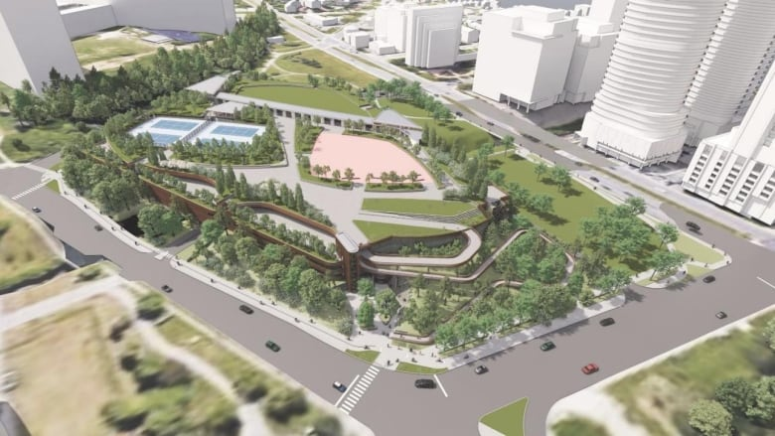

2. 1081 Carling Avenue - Proposal of two towers of 22 and 28 storeys
  - 1081 Carling Sub-Committee - Civic Hospital Neighbourhood Association (chnaottawa.ca)
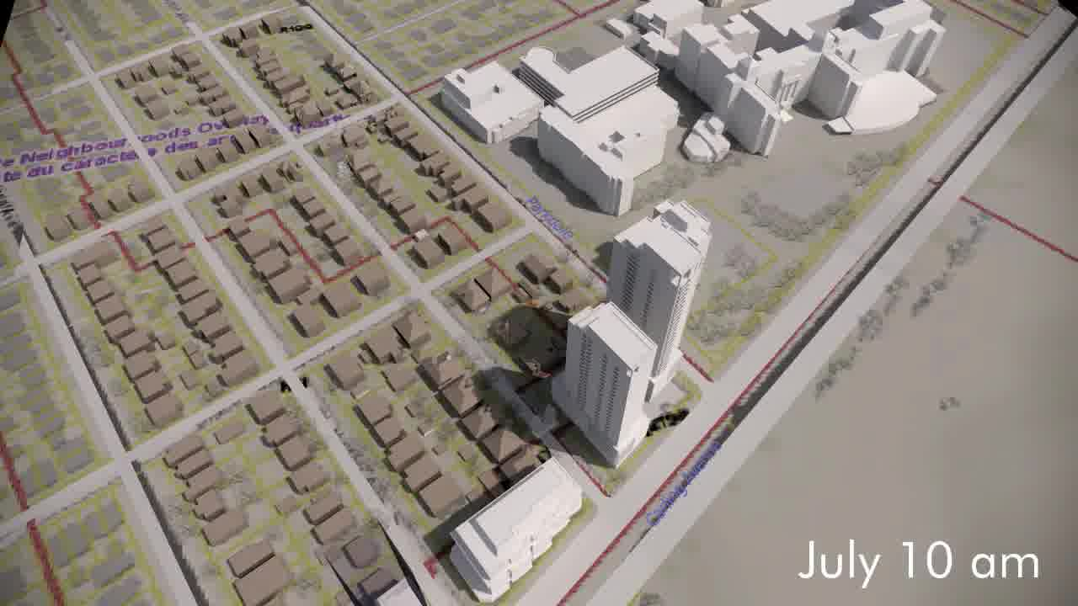

3. 30 Railway Street - Proposal of three storey, eight-unit low rise apartment dwelling
  - Planning and Development - Civic Hospital Neighbourhood Association (chnaottawa.ca)

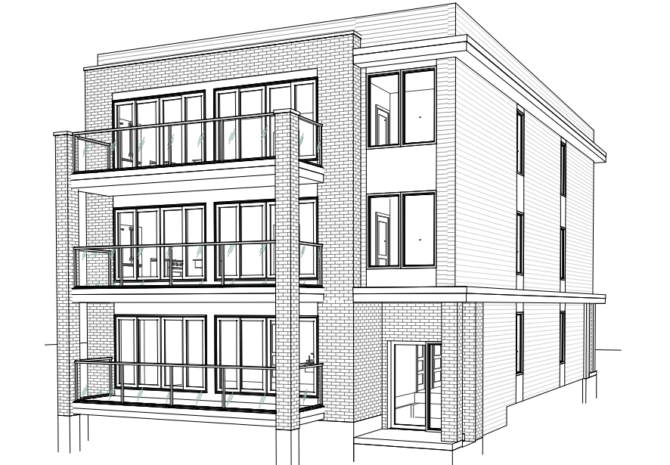

Overview of CHNA ACTIONS with Three Different Developments
Development | Positive Impacts | Negative Impacts and CHNA ACTIONS to Mitigate
1. The Ottawa Hospital New Civic Campus  - LOCATION: 930 Carling Avenue/520 Preston Street  - ESTIMATED COST: $2.8 billion development  -SCHEDULE: Ready by 2028  - STATUS:  First structure already approved by The City of Ottawa - Above ground four storey Parkade (February 2022) | -World Renowned Teaching Hospital specializing in trauma and Heart Institute  -Economic growth | - Threat to heritage designated sites - Central Experimental Farm, Queen Juliana Park –  CHNA ACTION: CHNA representation on The Ottawa Hospital New Civic Campus Advisory Committee to voice concerns on all potential negative impacts and propose solutions.  - Increase in Traffic -  CHNA ACTION: Include community in the study on Traffic  - Threat to mature trees -  CHNA ACTION:  - Accessibility given the nearly half-kilometre long connection between the current Carling O-Train station and the front doors of the future hospital. A "high-line" pathway would eventually cross the roof of the garage and arrive at the level of the hospital's doors –  CHNA ACTION:
2. Towers
- LOCATION:
1081 Carling
Proposal of two towers of 22 and 28 storeys
- ESTIMATED COST:
- SCHEDULE:
- STATUS:
3. Low Rise Apartment Dwelling
LOCATION:
30 Railway Street
Proposal of three storey, eight-unit low rise apartment dwelling
- ESTIMATED COST:
- SCHEDULE:
- STATUS:

ANNEX B
Impact of Surrounding Developments on Preston Street and Carling Avenue
45 Story Icon - Northeast corner of Preston Street; Up to 55 Floors, Three Tower Proposal – Northwest corner of Preston Street on former car dealership property
60 Storey Building – 829 Carling Avenue at Northwest corner of Preston Street, on CIBC Bank property Ottawa's tallest building will contain 459 units. The City's Planning Department has notified the public of City of Ottawa Official Plan amendment, zoning and site plan application to build this 60-storey tower. Federation of Citizens’ Associations of Ottawa (FCA) raises these questions to be addressed: How much parking do we need next to an LRT station? Are 6 storeys underground and 7 above ground enough? https://centretownbuzz.com/2021/11/skyline-another-preston-carling-tower-aims-high-is-it-a-reach-too-far/
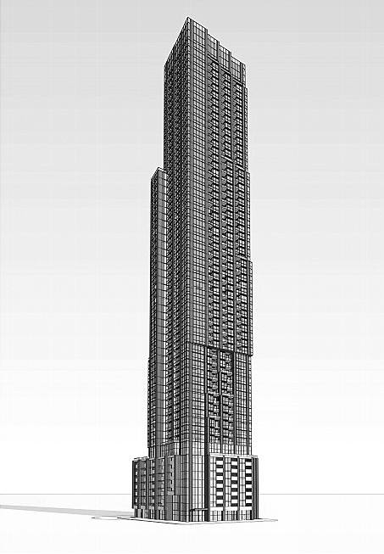

991 Carling Avenue
All_Image Referencing_Zoning Bylaw Amendment Application_Image Reference_D02-02-15-0077 Site Plan.PDF (ottawa.ca)
