Annual General Meeting Notes: 3 Nov 2015

- Review of Agenda and General Remarks: Karen Wright, President CHNA

- Guest Speaker: Marion Fraser CFO, VP Finance and Admin- University of Ottawa Heart Institute
  - UOHI Expansion Update
    - The parking lot on Ruskin Street was regraded and repaved
    - Access to the Melrose Entrance is from Melrose Ave. and the laneway from Ruskin St. is closed.
    - The current UOHI Ambulance Entrance will be closed to vehicular traffic but will remain accessible to pedestrians. Ambulance Services and Patient Transport Services are using the new temporary ambulance entrance on Melrose.
    - Construction of the new enclosed direct link between TOH and the UOHI new Tower started in June, however it will not be opened until the new Tower has been completed in January 2018.
    - The secure bike cage near Melrose Avenue will be removed and additional space will be added to the bike cage at the P1 parking garage.

  - Cyclotron/Radioisotope Safety Program
    - Background: The University of Ottawa Heart Institute has been operating a cyclotron safely for over 15 years producing medical radiopharmaceuticals for use in oncology, neurology and cardiology imaging procedures.
    - Public Information: The Canadian Nuclear Safety Commission (CNSC) now requires all operators of cyclotron facilities to make the public aware of the facility, how it operates and when we will notify the public of any health and safety related issues.
    - What is it: The cyclotron is a device used at UOHI to make short-lived radioisotopes to produce radiopharmaceuticals used for medical imaging and research.
    - Is it safe: Cyclotrons are considered to be a clean nuclear technology that produces very little radioactive waste. We operate a safe facility and have extensive operating and emergency measures in place to ensure the safety of patients, staff and the public at all times.
    - The radiopharmaceuticals produced by the UOHI cyclotron are used for an imaging modality called positron emission tomography (PET), used for:
      - Early and accurate detection of cancer
      - Detecting certain diseases of the heart and brain
    - The isotopes produced at UOHI have a very short half-life meaning that the tracer will decay and become inactive very quickly but it also means the tracers must be generated in close proximity to the PET scanner.
    - For more information, see: www.ottawaheart.ca/researchers/resources-services/core-facilities-and-infrastructure/pet-research-radiochemistry/public

- Finance Report: Julie Westall, Treasurer
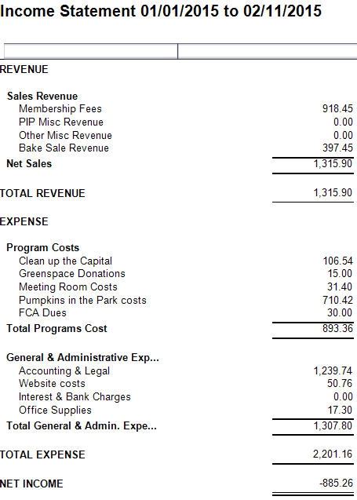

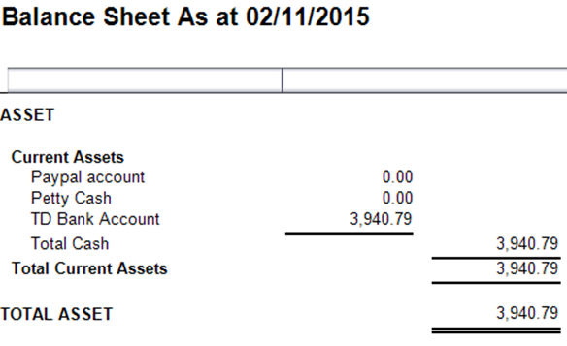

  - Members were asked to accept the financial report as presented
  - All members were in favour
  - Report is accepted.
- History and Heritage Update: Matt Lemay and Chris Uchiyama
  - History Pin: new feature on our website
    - Introduction to an on-line mapping tool that allows us to insert photos and historical facts about landmarks in our neighbourhood on a map
    - A number of pins/photos/facts have already been added, but neighbours are also welcome to add their own
    - https://www.historypin.org/en/civic-hospital-neighbourhood-history-heritage

  - Oral History Project
    - The History and Heritage Committee has launched an oral history project to enhance understanding of how our neighbourhood has changed over the years. We have already recorded the memories of several current and former residents, and we’re looking for new participants.
    - The stories collected so far recall the neighbourhood’s farmland days, the early years of the Civic hospital, the streetcar era, and fundraising bazaars and concerts organized by local pre-teens during the Second World War.
    - We are grateful to our pilot interviewees Libby Beckett, Margaret McGowan, and Elizabeth Truemner for sharing some of their memories of the neighbourhood.
    - If you would like to participate in the Oral History Project, contact Chris Uchiyamathe of the CHNA History and Heritage Committee at (613) 983-7503 or history@chnaottawa.ca.

- Election Time: 2016 CHNA Board
  - Roles and Nominees (*returning)
    - President – Karen Wright *
    - Vice President – Peter Eady*
    - Treasurer – Julie Westall*
    - Secretary – Katherine Steinhoff
    - Development – Kathy Kennedy*
    - Safety – Shane Quinn*
    - Transportation - Luanne Calcutt*
    - Communications - Alyson Queen*
    - Fundraising and Membership – Shelley Mullins*

  - Election to replace departing role of Secretary:
    - Sole nominee, Laurel McIvor, accepted nomination
    - Acclaimed to position

- Constitution Explained: Peter Eady, Vice President
CHNA became legally incorporated in May of this year. The new status gives us legal standing, as well as higher visibility and credibility with City Hall. It also gives members a clear democratic and governance framework in which all can participate.
  - All paid members are asked to sign and ratify the official By-Laws and Resolutions of the CHNA
    - Paper copies of the By-laws and Resolutions were circulated to the membership.
    - Members were asked to accept the By-laws and Resolutions as presented by adding their signature and name to the paper copy at the membership table (see attached pdf copies of CHNA Bylaws and Resolutions and member signatures).

- Kitchissippi Update – Councillor Leiper
  - Reid Park
    - Final recommendations about the re-shaping of Reid Park will be presented to the community by November 30, following public consultations in July and October. $1M has been reserved for the park and Councillor Leiper has been engaging the Association and the community for direction on how best to spend the money.
    - More details, plus contact information, on his website, kitchissippiward.ca.
    - If you have opinions and suggestions about the park’s future, please share them.

  - Hickory-Adeline Street Bridge
    - Check out the Hickory-Adeline Street pedestrian and cycling bridge, which officially opened on August 17!
    - Spanning the O-train corridor, this connection between Little Italy and the Civic Hospital neighbourhood is proving to be a popular addition to our community infrastructure.
    - Major Improvements to the Multi-Use Pathway (MUP) adjacent to the bridge are currently underway.

  - Urban Forest Management Plan consultation
    - The plan will provide a structured approach to protecting and enhancing the environmental, social and economical services provided by the urban forest.
    - The City of Ottawa has no overarching long-term vision and plan for our urban forest. Canada's Capital city has an opportunity to become a leader in urban forest management reinforcing the value of its green assets.
    - The project is starting this fall and will take a year and a half to complete. Your opportunity to get involved will begin this month. More info will be posted to http://ottawa.ca/en/city-hall/public-consultations/environment/urban-forest-management-plan as it becomes available.
- 8:30 pm Adjourned

